Qatar University
Programming Project: Elevator Optimization
Spring 2024
CMPS323 - L02
Design and Analysis of Algorithms
Dr. Mohammad Saleh and Alaa Hussein
May 2nd, 2024
By Mohammad Ahmad (202002453)

Introduction
In this assignment, the task was to optimize the number of stops an elevator makes with respect to the walking distance that riders would have to traverse as a result of each stop to their desired destinations. This distance can be either in the upwards or downwards direction, that is, riders will either have to walk up or down depending on what their destination is after departing from the elevator at the stop that it chooses. Out of the two approaches offered to choose from in order to solve this problem, the greedy approach was adopted as this offered a very simple solution.

Discussion
The main aspect of the greedy approach is to make locally optimal decisions, thus granting it the term “greedy”. This methodology does not necessarily always grant the most optimal solution in the grand scheme of things; however, it most definitely provides a very suitable (and also flexible) solution to the presented problem. Let us consider there to be a variable “x” (for the sake of simplicity) which represents the maximum amount of distance passengers are willing to travel in order to reach their desired destinations after the elevator reaches a stop. In a greedy approach, the elevator should consider stopping at a floor that is the middle point such that the distance from this floor to a “min-floor” and a “max-floor” equals “x”. In this way, certain floor groups would be formed based on certain logic. Consider the following diagram (please note that in this specific example, we are considering a case where the elevator is on the lowest floor (0) and is going to make a one-way trip to the highest request it receives. Different cases will be discussed later):
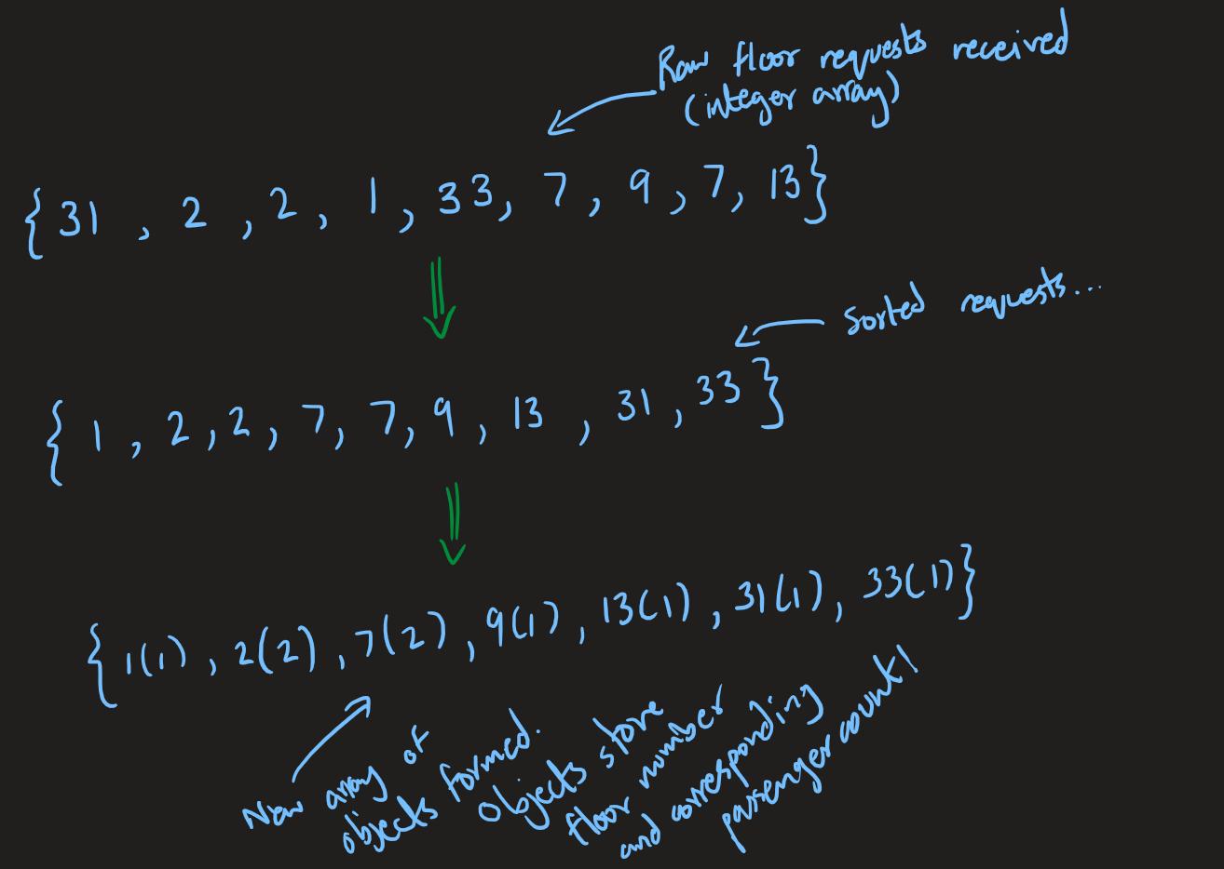

Riders will enter what floor they want to travel to through an elevator terminal present on the floor they are currently on. If we assume that this is a work setting, then the employees would be required to present their work IDs in order to access this terminal, this will also be helpful to keep track of the number of requests to a floor as each employee’s request to a floor will be counted as one rider requesting the elevator to take them to that floor. Any subsequent employees later requesting the elevator to take them to the same floor adds onto the “count” of the floor’s requests, thereby recording the number of passengers who want to get off at each floor. Getting back to the point, the inputs received by the elevator will then get sorted into an integer array of ascending order, which then gets interpreted into an array of objects that stores the floor requests along with the amount of riders that requested a certain floor. Moving on, consider the following approach:
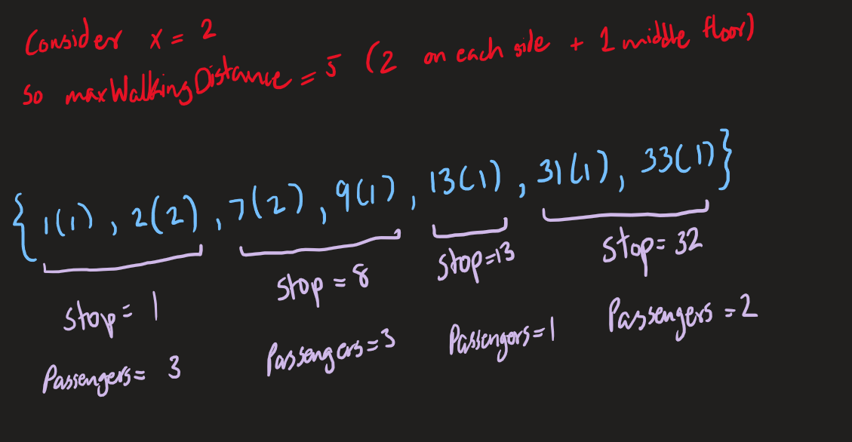
We can see that we introduced something called “maxWalkingDistance”. This is basically the count of the number of floors the elevator considers above a specific floor of reference. This distance must be an odd number as there must be a middle floor, so it is calculated by “2x + 1”. The elevator will always use a reference floor, and this will be the first floor that the elevator sees in the list that it has not stopped at, or rather, not included in a group that a stop covers. Let us look at the example of floor 1 as this is the floor that is closest to the elevator for its upwards journey. Adding 5 to 1 gives 6, which means that any floors between 1 (inclusive) and 6 (exclusive) would be grouped together. The elevator would then consider the minimum floor number and maximum floor number that it has found within this range and from this information, calculate the middle floor from these. In the case that there is no middle floor (the difference between minimum and maximum floors is even, or the range only includes 2 floors), the elevator will choose the floor closer to the minimum floor in order to conserve power. So, in our example, it groups floors 1 and 2 and decides to stop at floor 1 as it is the lower floor. Similarly, adding 5 to 7 gives us 12, so any floors between 7 (inclusive) and 12 (exclusive) are included in the next group. This leads to floors 7 and 9 being grouped and thus the elevator stopping at the middle floor (floor 8 in this case), and it continues on until the elevator has completed its upwards journey.

If we consider a theoretical case where floors 1, 2, 3, 4, 5, and 6 were requested, floors 1 to 5 would be grouped with the elevator stopping at floor 3 as it is equally as far from the maximum and minimum floors within the range. “x” between 1 and 3 would be 2, likewise it would be 2 between 3 and 5. The elevator would then stop at floor 6 separately as it was not included in any group. In this way, instead of stopping at 6 individual floors, the elevator only stops at 2 floors while also regarding the amount of distance passengers are willing to walk to their destination from a given “stop” floor. “x” can be varied as per the agreement of the employees, so the algorithm is also flexible in that case.

Conclusion

